EE 255 – SINGLE PHASE TRANSFORMER

SAMARAKOON S.M.O.T.

E/21/345

GROUP EE.21.B.23

SEMESTER 04

13.07.2025

**PRELAB**

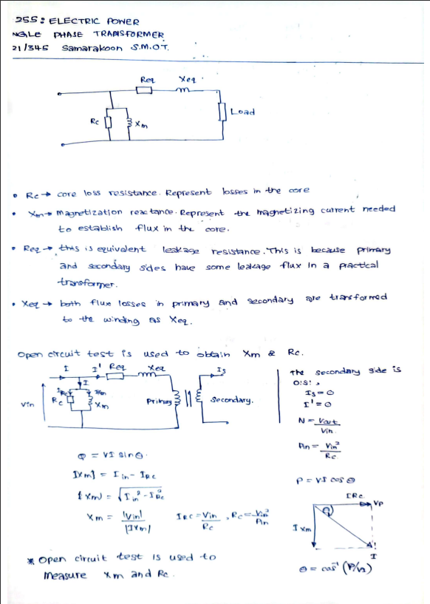

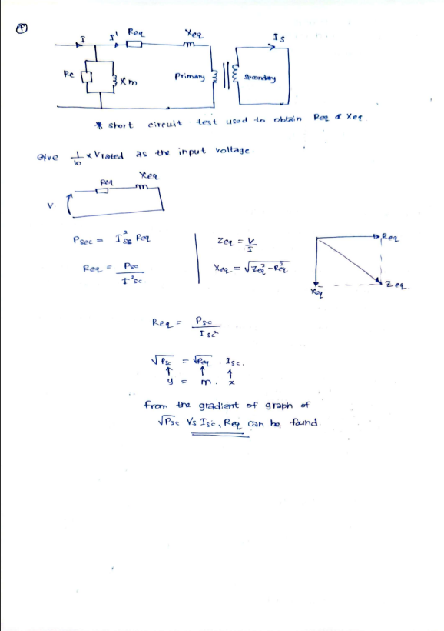

**EE 255: ELECTRIC POWER**

**Experiment: Single Phase Transformer**

**(3 hours)**

**DATE: 02/07/2025**

**REG. NO: E/21/029**

**INTRODUCTION:**

Students are given hand on experience in determining the approximate equivalent circuit of a single phase transformer by using the results obtained from the open circuit test and the short circuit test.

Students can get an idea about the losses associate with a transformer at the same time typical variation of the efficiency and the voltage regulation of a single phase transformer for different loadings.

**LEARNING OUTCOMES:**

LO 1: Describe different magnetic circuits, their properties and appreciate losses associated with them.

LO 2: Perform the open circuit and short circuit tests on a single phase transformer.

LO 3: Estimate the parameters in the equivalent circuit of a single phase transformer.

LO 4: Calculate voltage regulation and efficiency of a transformer using the equivalent circuit.

LO 5: To perform the load test on a single phase transformer and determine its voltage regulation and efficiency at each of the loading level.

**THEORY:**

Approximate equivalent circuit of a single phase transformer is shown below.

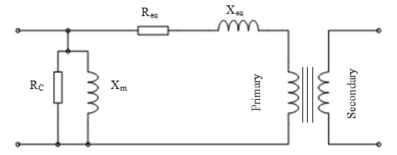

R

C

X

m

R

eq

eq

Secona

Prima

Figure 01: Approximate Equivalent Circuit of a Single Phase Transformer

# Open Circuit Test

The purpose of this test is to determine the shunt branch parameters of the equivalent circuit of the transformer.

In this test one of the windings is connected to supply at rated voltage, while the other winding is kept open – circuited.

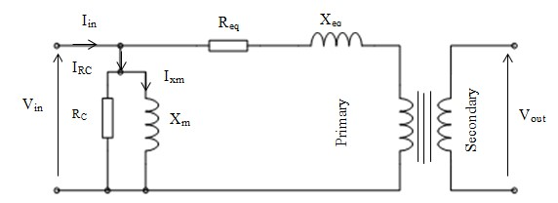

## Figure 02: Open Circuit Test

As secondary is open circuited, the current through Xeq and Req can be neglected.

Turns ratio N,

N = Vout / Vin

Pin= Vin2/ RC

Pin, Iin, Vin and Vout can be measured in the practical. Therefore, RC can be found using the above equation.

IRC = Vin / RC ixm = iin - iRc

|Ixm|= (Iin2 – IRc2 )1/2

|Xm|= |Vin| / |Ixm|

Xm can be found by using above equations.

# Short Circuit Test

This test serves the purpose of determining the series parameters of a transformer.

For convenience of supply arrangement and voltage and current to be handled, the test is usually conducted from the HV side of the transformer while the LV side is short-circuited.

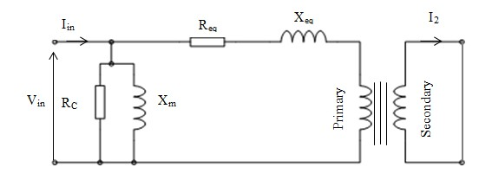

## Figure 03: Short Circuit Test

RC and Xm can be neglected as a lower voltage are applied.

PSC = ISC2 * Req

(PSC)1/2 = (Req)1/2. ISC

Y = m1. X

From the gradient m1 of the graph of (PSC)1/2 Vs. ISC, Req can be found.

Zp = |VSC |/ |ISC|

VSC =Zp .ISC

Y = m2. X

From the gradient m2 of the graph VSC Vs. ISC, Zp can be found.

Zp = (Req2 +Xeq2)1/2

From the above equation Xeq can be found.

**PROCEDURE:**

# (a). Open Circuit Test

## Apparatus

1. Single phase transformer (230/115V, 1.1 kVA,50 Hz)
2. Variac (230V, 50 Hz)
3. Rheostats – 2 Nos (1030Ω/1A & 1Ω/13A)
4. Wattmeter (240V/1A)
5. Voltmeters – 2 Nos(0-300V & 0- 150V)
6. Ammeter (0-1A)

## Procedure

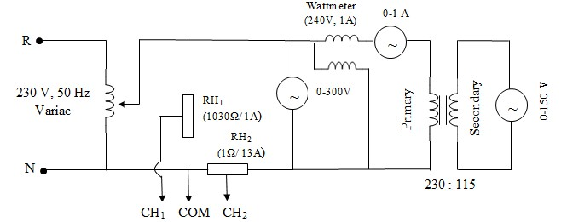

### Figure 04: Open Circuit Test Circuit Diagram

1. Connect the circuit as shown in Figure 04. (Do not connect the C.R.O. probes to the circuit until the instructor checks the circuit.)
2. Show the connected circuit to the instructor.
3. Set the **Variac to zero** **position** and Rheostat 1 (RH1) and Rheostat 2 (RH2) to the minimum position.
4. Power on the AC voltage supply.
5. Adjust the Variac and set the secondary voltage to 115V.
6. Record the readings of Wattmeter, ammeter and Voltmeters.
7. Connect the C.R.O. probes and adjust the rheostats (RH1 and RH2) slightly to get the full waveform on the screen.
8. Record the voltage and magnetizing current waveforms.
9. Now bring the Variac to zero volts and Switch off the power supply.

## Observations

|  |  |  |
| --- | --- | --- |
| Voltmeter reading | Ammeter reading | Wattmeter reading |
| 230 V | 0.11 A | 14 W |

## Calculations

• Calculate RC and Xm referred to the primary side of the transformer by using Open Circuit Test results.

# (b). Short Circuit Test

## Apparatus

1. Single phase transformer (230/115V, 1.1 kVA,50 Hz)
2. Variac (230V, 50 Hz)
3. Wattmeter (120V/1A)
4. Voltmeter (0-75V)
5. Ammeter (0-5A)

## Procedure

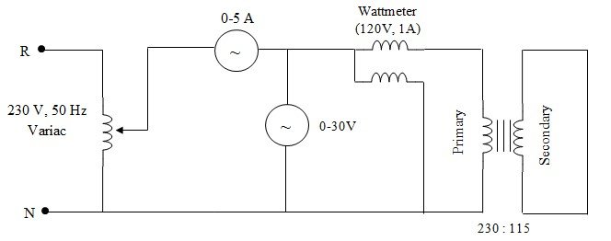

### Figure 05: Short Circuit Test Circuit Diagram

1. Connect the circuit as shown in Figure 05.
2. Show the connected circuit to the instructor.
3. Make sure the **Variac is at Zero volt position**.
4. Power on the AC supply.
5. Adjust the Variac and record the readings of the voltmeter, ammeter and wattmeter for ammeter readings from 0 to 4 A by 0.5 A steps. (**Do not exceed the current beyond 4 A.**)
6. Rotate the Variac to zero and switch off the power supply after the experiment.

## Observations

|  |  |  |
| --- | --- | --- |
| Ammeter Reading | Voltmeter Reading | Wattmeter Reading |
| 0.0 | 0.0 | 0 |
| 0.5 | 2.0 | 2 |
| 1.0 | 5.0 | 5 |
| 1.5 | 7.0 | 10 |
| 2.0 | 10.0 | 17 |
| 2.5 | 12 | 26 |
| 3.0 | 14.5 | 40 |
| 3.5 | 16.5 | 54 |
| 4.0 | 19.0 | 71 |

## Calculations

* Plot the following graphs.

1. Voltage Vs. Current

**ii.** (Power)1/2 Vs. Current

* Calculate Req and Xeq referred to the primary side of the transformer by using Short Circuit Test results.

## RESULTS

|  |  |
| --- | --- |
| RC |  |
| Xm |  |
| Req | $$4.24 Ω$$ |
| Xeq |  |

• Draw the approximate equivalent circuit of the single phase transformer referred to primary side with mentioning calculated parameter values.

# (c). Load Test

## Apparatus

1. Single phase transformer (230/115V, 1.1 kVA,50 Hz)
2. Variac (230V, 50 Hz)
3. Wattmeters – 2 Nos (240V/25A)
4. Voltmeters – 2 Nos (0-300V & 0-150V)
5. Ammeters – 2 Nos (0-5A & 0-25A)
6. Water Load

## Procedure

**v**

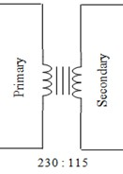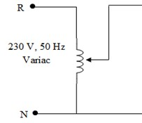

V

A

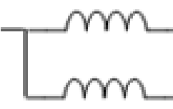

V

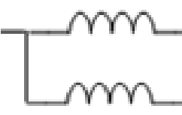

A

0

-

300

V

Wattmeter

240

V

/25A

0

-

A

5

0

-

15

V

0

Water

Load

Wattmeter

240

V

/25A

0

-

25

A

### Figure 6: Load test circuit diagram

1. Connect the circuit as shown in figure 6 and set the variac to zero position.
2. Set water load positions to “Low”.
3. Adjust the variac and set the primary voltage to 230V.
4. Record the readings of Wattmeters, ammeters and voltmeters for different water load positions.

**Observations**

|  |  |  |  |  |  |  |  |
| --- | --- | --- | --- | --- | --- | --- | --- |
| Water  Load position | Percentage full load(%) |  | Primary Side |  | Secondary Side | | |
| Voltmeter/V | Ammeter/A | Wattmeter/W | Voltmeter/V | Ammeter/A | Wattmeter/W |
| LLL | 30 | 230 | 1.9 | 430 | 112 | 3.6 | 420 |
| LLM | 40 | 230 | 2.5 | 570 | 112 | 4.9 | 540 |
| LMM | 50 | 230 | 1.55 | 350 | 114 | 2.9 | 340 |
| MMM | 60 | 230 | 2.00 | 460 | 112 | 3.9 | 440 |
| MMH | 80 | 230 | 2.95 | 680 | 110 | 5.8 | 650 |

## Calculations

Considering the 5th data set of the table,

PP=VP.IP.Cos(θ),

Power Factor, Cos(θ) = PP / (VP.IP)

= 680/(230*2.95)

= 1.002

Voltage regulation = (VNL – VFL) × 100

VFL

=((115-110)*100)/110

= 4.55 $\%$

Efficiency = POUT × 100

PIN

=(650/680)*100

= $95.59\%$

## Results

|  |  |  |  |
| --- | --- | --- | --- |
| Percentage full load (%) | Power Factor | Voltage Regulation (%) | Efficiency (%) |
| 30 | 0.984 | 2.68 | 97.67 |
| 40 | 0.991 | 2.68 | 94.74 |
| 50 | 0.982 | 0.877 | 97.14 |
| 60 | 1.000 | 2.68 | 95.65 |
| 80 | 1.002 | 4.55 | 95.59 |

• Plot the variation of Voltage regulation Vs. percentage full load and Efficiency Vs. Full load

## PROBLEM

Using the approximate equivalent circuit shown in Figure 01 and equivalent parameters calculated from Open circuit and Short circuit test, calculate the **Voltage Regulation** and **Efficiency** of the transformer for 30%, 40%, 50%, 60% and 80% of full load. Assume a unity power factor. Tabulate the results.

## DISCUSSION

1. Does the core loss vary with the load? Why?
2. In the open circuit test, why the copper loss in the primary can be neglected?
3. In the short circuit test, why can the core loss be neglected?
4. Discuss any three points, which you have gained from this experiment. If any practical problems observed that can also be included in this discussion.
5. Compare voltage regulation and efficiency obtained during load test with theoretically calculated values in PROBLEM.

**CALCULATIONS**

**Part a)**

Calculate RC and Xm referred to the primary side of the transformer by using Open Circuit Test results.

$$P_{in}= \frac{V_{in}^{2}}{R_{C}} \\ R_{C}= \frac{{230}^{2} V^{2}}{14 W} \\ R_{C}=3778.571 Ω \\ I_{RC}= \frac{V_{in}}{R_{C}} \\ =\frac{230 V}{3778.571 Ω} \\ I_{RC}= 60.869 mA \\ I_{Xm}= \sqrt{I_{in}^{2}- I_{RC}^{2}} \\ =\sqrt{{0.11}^{2}-{0.060869}^{2}} A \\ I_{Xm}=91.60 mA \\ \left|X_{m}\right|=\frac{\left|V_{in}\right|}{\left|I_{Xm}\right|} \\ =\frac{230 V}{91.60 mA} \\ X_{m}=2510.970 Ω$$

**Part b)**

**TABULATION**

Table 1: Variation of voltage with current

|  |  |
| --- | --- |
| Current (A) | Voltage (V) |
| 0.0 | 0.0 |
| 0.5 | 2.0 |
| 1.0 | 5.0 |
| 1.5 | 7.0 |
| 2.0 | 10.0 |
| 2.5 | 12.0 |
| 3.0 | 14.5 |
| 3.5 | 16.5 |
| 4.0 | 19.0 |

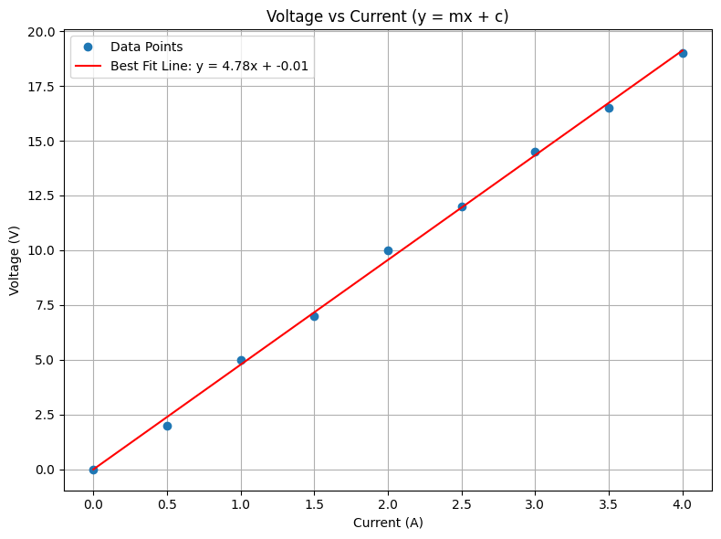

### Figure 7: Variation of voltage with current

**TABULATION**

Table 2: Variation of (Power)1/2 with current

|  |  |
| --- | --- |
| Current (A) | Power1/2 (W1/2) |
| 0.0 | 0.00 |
| 0.5 | 1.41 |
| 1.0 | 2.24 |
| 1.5 | 3.16 |
| 2.0 | 4.12 |
| 2.5 | 5.39 |
| 3.0 | 6.32 |
| 3.5 | 7.35 |
| 4.0 | 8.43 |

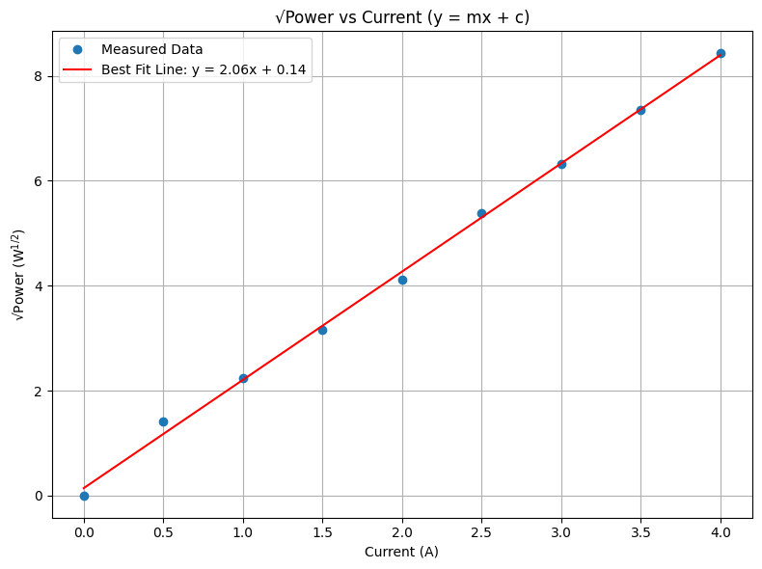

### Figure 8: Variation of Power1/2 with current

Let,

$$m_{1}=gradient of figure 7 \\ m_{2}=gradient of figure 8 \\ m_{1}=4.78 V/A \\ m_{2}=2.06 W^{\frac{1}{2}}/A$$

From figure 8,

$$P_{SC}= I_{SC}^{2} × R_{eq} \\ {\left(P_{SC}\right)}^{\frac{1}{2}}= {{(R}_{eq}) }^{\frac{1}{2}}× I_{SC} \\ y=m_{2} × x \\ {{(R}_{eq}) }^{\frac{1}{2}}= m_{2} \\ =2.06 \\ R_{eq}=4.24 Ω$$

From figure 7,

$$Z_{eq}= \frac{\left|V_{SC}\right|}{\left|I_{SC}\right|} \\ V_{SC}= Z_{eq} × I_{SC} \\ y=m_{1} × x \\ Z_{eq}= m_{1} \\ =4.78 \\ X_{eq}= \sqrt{{{(Z}_{eq}) }^{2}- {{(R}_{eq}) }^{2}}$$ $=\sqrt{{4.78}^{2}-{4.24}^{2}}$

$X_{eq}=2.207 Ω$

**Part c)**

Considering the 1st data set of the table,

$$P_{P}= V_{P}.I_{P}.\operatorname{Cos}\left(θ\right) \\ Power factor, Cos\left(θ\right)= \frac{P_{P}}{V_{P}.I_{P}} \\ =\frac{450 W}{230 ×1.9 VA} \\ =1.03 \\ Voltage regulation=\frac{{(V}_{NL}- V_{FL})}{V_{FL}} ×100 \\ = \frac{\left(115-112\right)}{112} ×100 \\ =2.68\% \\ Efficiency= \frac{P_{OUT}}{P_{IN}} ×100 \\ = \frac{410}{450} ×100 \\ = 91.11\%$$

**RESULTS**  
  
**Part a), b)**

|  |  |
| --- | --- |
| RC |  |
| Xm |  |
| Req | $$4.24 Ω$$ |
| Xeq |  |

### 

Figure 9: Approximate equivalent circuit referred to primary side

Xeq = 4.16 Ω

Req = 4.16 $Ω$

Secondary

Primary

Xm = 2510.92 Ω

RC = 3778.57 Ω

**Part c)**

|  |  |  |  |
| --- | --- | --- | --- |
| Percentage full load (%) | Power Factor | Voltage Regulation (%) | Efficiency (%) |
| 30 | 0.984 | 2.68 | 97.67 |
| 40 | 0.991 | 2.68 | 94.74 |
| 50 | 0.982 | 0.877 | 97.14 |
| 60 | 1.000 | 2.68 | 95.65 |
| 80 | 1.002 | 4.55 | 95.59 |

**TABULATION**

Table 3: Variation of voltage regulation with percentage full load

|  |  |
| --- | --- |
| Percentage full load (%) | Voltage regulation (%) |
| 30 | 2.68 |
| 40 | 2.68 |
| 50 | 0.877 |
| 60 | 2.68 |
| 80 | 4.55 |

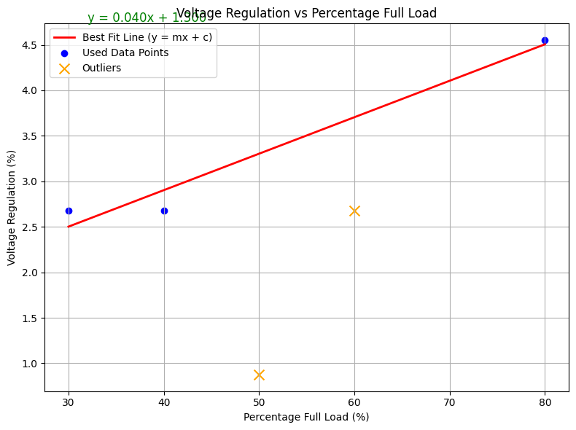

Figure 10: Variation of voltage regulation with percentage full load

### 

**TABULATION**

Table 4: Variation of efficiency with percentage full load

|  |  |
| --- | --- |
| Percentage full load (%) | Efficiency (%) |
| 30 | 97.67 |
| 40 | 94.74 |
| 50 | 97.14 |
| 60 | 95.65 |
| 80 | 95.59 |

* Neglecting third and fourth data set because of fault in water load,

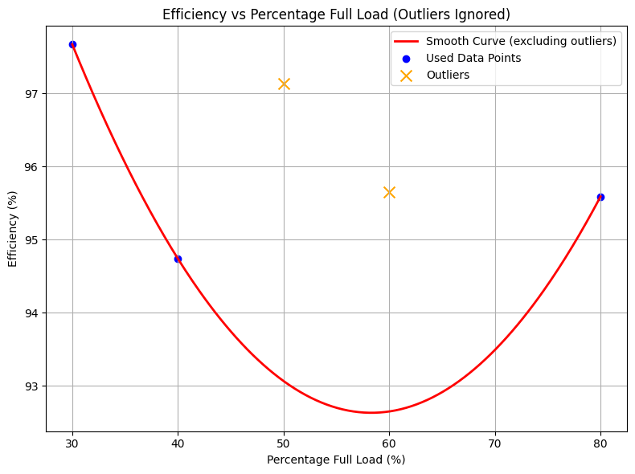

### Figure 11: Variation of efficiency with percentage full load

**PROBLEM**

Using the approximate equivalent circuit shown in Figure 01 and equivalent parameters calculated from Open circuit and Short circuit test, calculate the Voltage Regulation and Efficiency of the transformer for 30%, 40%, 50%, 60% and 80% of full load. Assume a unity power factor. Tabulate the results.

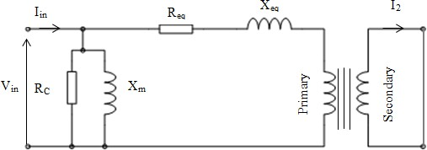

V1

E1

Ip

Is

115 V



Figure 12: Equivalent Circuit shown in Figure 1

KVL to primary, $$\begin{aligned}V_{1}=E_{1}+ I_{p }\left(R_{eq} + X_{eq}j \right)\#\left(1\right)\end{aligned}$$

## 1. 30% Full Load

* Secondary current ($I_{s}$): $0.3×9.57=2.87 \text{A}$
* Primary current ($I_{p}$): $2.87/2=1.44 \text{A}$

### **Calculations:**

1. Primary voltage ($V_{1}$):
$$V_{1}=230+1.44×(4.24+j2.207)=236.13∠{0.77}^{∘} \text{V}$$

2. Voltage regulation (VR%):
$$VR\%=\frac{236.13-230}{230}×100=2.67\%$$

3. Output power ($P_{out}$):
$$P_{out}=115×2.87=330.05 \text{W}$$

4. Power loss ($P_{loss}$):
   * Copper loss: ${1.44}^{2}×4.24=8.79 \text{W}$
   * Core loss: $\frac{{230}^{2}}{3778.571}=14.00 \text{W}$
   * Total loss: $8.79+14.0=22.79 \text{W}$
5. Input power ($P_{in}$):
$$P_{in}=330.05+22.79=352.84 \text{W}$$

6. Efficiency ($η$):

$$η=\frac{330.0}{352.84}×100=93.67\%$$

## 2. 40% Full Load

* Secondary current ($I_{s}$): $3.83 \text{A}$
* Primary current ($I_{p}$): $1.91 \text{A}$

### **Calculations:**

1. Primary voltage ($V_{1}$):
$$V_{1}=230+1.91×(4.24+j2.207)=238.14∠{1.01}^{∘} \text{V}$$

2. Voltage regulation (VR%):
$$VR\%=\frac{238.14-230}{230}×100=3.57\%$$

3. Output power ($P_{out}$):
$$P_{out}=115×3.83=440.45 \text{W}$$

4. Power loss ($P_{loss}$):
   * Copper loss: ${1.91}^{2}×4.24=15.47 \text{W}$
   * Core loss: $\frac{{230}^{2}}{3778.571}=14.00 \text{W}$
   * Total loss: $15.47+14.00=29.47 \text{W}$
5. Input power ($P_{in}$):
$$P_{in}=440.45+29.47=469.92 \text{W}$$

6. Efficiency ($η$):

$$η=\frac{440.45}{469.92}×100=93.73\%$$

## 3. 50% Full Load

* Secondary current ($I_{s}$): $4.785 \text{A}$
* Primary current ($I_{p}$): $2.39 \text{A}$

### **Calculations:**

1. Primary voltage ($V_{1}$):
$$V_{1}=230+2.39×(4.24+j2.207)=240.19∠{1.26}^{∘} \text{V}$$

2. Voltage regulation (VR%):
$$VR\%=\frac{240.19-230}{230}×100=4.43\%$$

3. Output power ($P_{out}$):
$$P_{out}=115×4.785=550.03\text{W}$$

4. Power loss ($P_{loss}$):
   * Copper loss: ${2.39}^{2}×4.24=24.22 \text{W}$
   * Core loss: $\frac{{230}^{2}}{3778.571}=14.00 \text{W}$
   * Total loss: $38.22 \text{W}$
5. Input power ($P_{in}$):
$$P_{in}=550.03+38.22=588.25 \text{W}$$

6. Efficiency ($η$):

$$η=\frac{550.03}{588.25}×100=93.50\%$$

## 4. 60% Full Load

* Secondary current ($I_{s}$): $5.74 \text{A}$
* Primary current ($I_{p}$): $2.87 \text{A}$

### **Calculations:**

1. Primary voltage ($V_{1}$):
$$V_{1}=230+2.87×(4.24+j2.207)=242.25∠{1.50}^{∘} \text{V}$$

2. Voltage regulation (VR%):
$$VR\%=\frac{242.25-230}{230}×100=5.33\%$$

3. Output power ($P_{out}$):
$$P_{out}=115×5.74=660.10 \text{W}$$

4. Power loss ($P_{loss}$):
   * Copper loss: ${2.87}^{2}×4.24=34.92 \text{W}$
   * Core loss: $\frac{{230}^{2}}{3778.571}=14.00 \text{W}$
   * Total loss: $48.92\text{W}$
5. Input power ($P_{in}$):
$$P_{in}=660.10+48.92=709.02 \text{W}$$

6. Efficiency ($η$):

$$η=\frac{660.10}{709.02}×100=93.10\%$$

## 5. 80% Full Load

* Secondary current ($I_{s}$): $7.66 \text{A}$
* Primary current ($I_{p}$): $3.83 \text{A}$

### **Calculations:**

1. Primary voltage ($V_{1}$):
$$V_{1}=230+3.83×(4.24+j2.207)=246.38∠{1.97}^{∘} \text{V}$$

2. Voltage regulation (VR%):
$$VR\%=\frac{246.38-230}{230}×100=7.12\%$$

3. Output power ($P_{out}$):
$$P_{out}=115×7.66=880.90 \text{W}$$

4. Power loss ($P_{loss}$):
   * Copper loss: ${3.83}^{2}×4.24=62.20 \text{W}$
   * Core loss: $\frac{{230}^{2}}{3778.571}=14.00 \text{W}$
   * Total loss: $76.20 \text{W}$
5. Input power ($P_{in}$):
$$P_{in}=880.90+76.20=957.10 \text{W}$$

6. Efficiency ($η$):

$$η=\frac{880.90}{957.10}×100=92.26\%$$

Table 5: Results for theocratically obtained Voltage regulation and Efficiency

|  |  |  |
| --- | --- | --- |
| Percentage full load (%) | Voltage Regulation (%) | Efficiency (%) |
| 30 | 2.67 | 93.67 |
| 40 | 2.67 | 93.67 |
| 50 | 4.43 | 93.50 |
| 60 | 5.33 | 93.10 |
| 80 | 7.12 | 92.26 |

## DISCUSSION

1. Does the core loss vary with the load? Why?
2. In the open circuit test, why the copper loss in the primary can be neglected?
3. In the short circuit test, why can the core loss be neglected?
4. Discuss any three points, which you have gained from this experiment. If any practical problems observed that can also be included in this discussion.
5. Compare voltage regulation and efficiency obtained during load test with theoretically calculated values in PROBLEM.